Jayden Respicio & Clark Hayashi
BUAN 4220 – Data Visualization

Our project was focusing on Hawaii listings from the perspective of a guest or visitor. Using a dataset of ~36,000 listings, we examined Airbnb prices, locations by island and neighborhood, and user reviews. We also compared Airbnb prices to average hotel rates (based on Google estimates for 3 & 4-star hotels). For our story or objective, we wanted to look at where guests can find better value in looking at a hotel or an Airbnb and how that looks on the different islands and their neighborhoods.

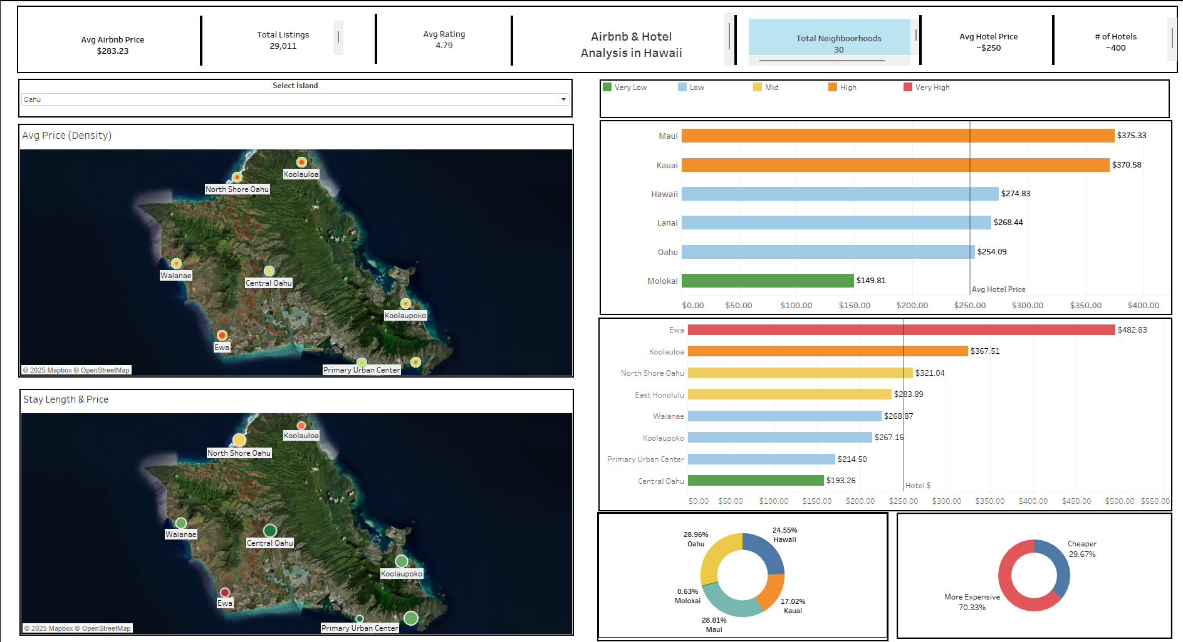

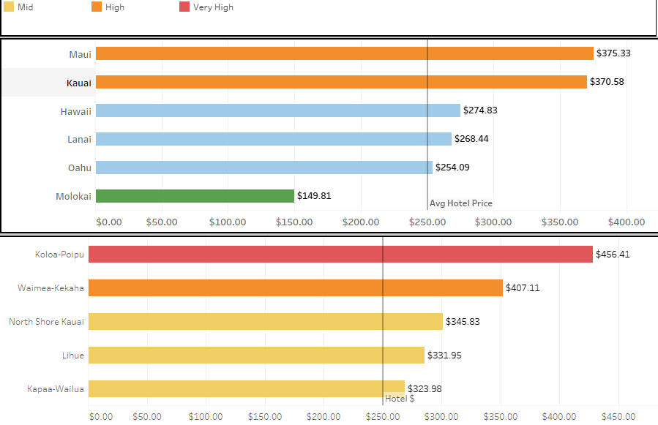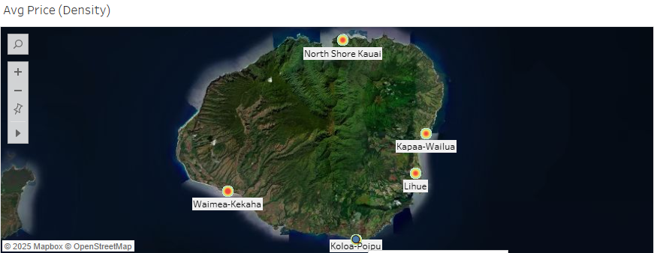
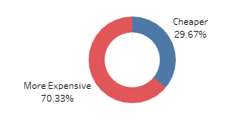

Main takeaways:
- Hotels are cheaper on average ($250 vs. $283 for Airbnb).
- Reviews were pretty high, with the average being 4.79/5, so you were generally getting a great place for Airbnb.
- 70% of Airbnb listings (under $1,000) are more expensive than hotels.
- Maui and Kauai are the most expensive islands, while Molokai offers the lowest average prices.
- Oahu has the most listings (~29% of all), but prices are more moderate compared to other islands.
- Generally, the locations that were more expensive seemed to be more closer to water. Kauai makes this obvious since all those neighborhoods are close to water and all neighborhoods are more expensive than the average hotel price, unlike on Oahu, where Central Oahu is in the middle of the island and has a more budget-friendly option.

